
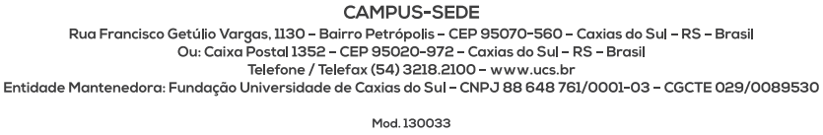

SELECTION PROCESS FOR ADMISSION TO THE POSTGRADUATE PROGRAM IN PHILOSOPHY – MASTER’S DEGREE
ANNEX I
SELF-DECLARATION FOR BLACK PEOPLE
I (full name – without abbreviations __________________________________
_____________________________________________, registered with CPF or Passport number ____________________________ and holder of ID number ___________________________, DECLARE that I am a black person ( ) and eligible to apply for the vacancies reserved for black people established by the affirmative action policies outlined in the Selection Process for admission to the Postgraduate Program in Philosophy – Master’s Degree – Main Campus, at the University of Caxias do Sul (UCS).
I also declare full knowledge and agreement with the following:
I – The self-declaration submitted will be evaluated by an Institutional Committee, which may, if deemed necessary, call me for an interview at any time; and
II – If the falsity of this self-declaration is confirmed by the Institutional Committee, determined through its own procedure at any time, I will be subject to the applicable legal measures, including the loss of the position in the mentioned selection process.

__________________________, _____ of _______ 20___.

________________________________
Signature of the declarant

